AI Research Paper Assistant: Local M4 Prototype to Production Blueprint
Nov 1, 2026 · @Someone

At a glance
The design scales by keeping the shape and swapping the substrate. The same typed agent loop, Proxy-Pointer retrieval and per-slot token budgets run on a 24 GB M4 Pro and on a GPU cluster. Narrow interfaces (an inference port, a store port, a job port) are the only code that changes between the two.
On the laptop, the bottleneck is memory bandwidth and the 16 GB GPU share of unified memory, so the design minimizes bytes per token. In production, the bottleneck is GPU utilization under many concurrent users, so the design maximizes batching and cache reuse while making every request stateless, traceable and guarded.
Layer | Local M4 Pro prototype | Production product
Inference | Ollama (llama.cpp, Metal backend), 7B at Q4_K_M, one request at a time | vLLM pods on GPUs, continuous batching, prefix caching, autoscaled by queue depth
Structured output | JSON schema in Ollama format + Pydantic validate and re-ask | Same schemas through vLLM structured outputs; same validators
Retrieval index | Embedded: SQLite FTS5 + in-process vectors (FAISS when the library grows) | Qdrant or Milvus (or pgvector under ~10M vectors) with tenant filters
Agent state and memory | Same SQLite file, one transaction | PostgreSQL (source of truth) + Redis (hot session state, locks, rate limits)
Work execution | asyncio tasks in one process, one ingestion worker | Message queue (RabbitMQ or Kafka) feeding stateless worker pools
Observability | Structured logs + persisted run events | OpenTelemetry GenAI spans into Langfuse, metrics, alerts, evals
Guardrails | Schema validation, step caps, citation checks | Plus input and document injection screening, output policy checks, authz on every tool

1. Architectural synthesis
Four patterns carry the whole system. Each one holds in both environments; only its implementation changes.

1.1 Context window optimization
Treat the context window as a budget, not a buffer. Anthropic's context engineering guidance frames the goal as the smallest set of high-signal tokens. For a 7B model that is a hard constraint: quality drops well before the advertised window fills.
- Slot budgets: a ContextAssembler fills fixed slots in a fixed order (system, tools, memory, history, sources, output reserve). Each slot has a token cap, and the slots sum to at most 90% of num_ctx, so estimation error never truncates silently.
- Retrieve sections, not chunks (Proxy-Pointer): embed small breadcrumbed pointers, then load the whole section on a hit. Precision comes from small vectors; coherence comes from whole sections.
- Stable prefixes: system prompt and tool schemas are byte-identical across turns, so the runtime reuses the KV cache for the prefix. Locally that saves prefill time on every turn. In production, vLLM automatic prefix caching shares that prefix across users.
- Compaction and notes: older turns fold into a rolling summary once, incrementally. Findings go to a notebook outside the window, so a multi-paper comparison survives a context reset.
- Constrained decoding for every machine-read step: routing, tool choice, metadata and verification are JSON-schema-constrained. Free text is reserved for the final answer.

1.2 Agent memory layers
Layer | Holds | Lifetime | Local store | Production store
Working | The exact prompt for one call | One call | In process | In process (stateless worker)
Short-term | Recent turns, rolling summary, this run's tool results | One session | SQLite | Redis (hot) + PostgreSQL (durable)
Episodic | What happened: runs, questions, sources used, feedback | Permanent, ranked by recency | SQLite + vectors | PostgreSQL + vector store
Semantic | Distilled facts with provenance and validity | Until invalidated | SQLite + vectors | PostgreSQL + vector store, per tenant
Procedural | Prompts, tool contracts, routing rules | Versioned releases | Code | Code + prompt registry with versions
Memory is mostly write-side work (extraction, deduplication, invalidation), which a vector index does not do. Vectors are one retrieval method inside the memory layer, not the memory layer itself.

1.3 Operational state store
Every run is a row with a typed, checkpointed state and an append-only event log. This is what makes runs resumable, replayable to a reconnecting client, auditable, and testable. State lives in a database the application owns, never inside a framework's in-memory object. In production the same record becomes the contract between stateless workers: any worker can pick up a run from its last checkpoint.

1.4 Native vs framework orchestration
Anthropic's guidance is to start with simple, composable patterns and direct API calls, adding agentic steps only when simpler paths fall short. For small models this matters more: they plan poorly, so code should own control flow and the model should make bounded choices.
Dimension | Native Python (asyncio + Pydantic) | Heavy framework (LangChain agents, large graph runtimes)
Prompt control | Every prompt is a visible string you tuned for the SLM | Hidden templates tuned for frontier models
Debugging | Stack traces point at your code; nodes unit-test in isolation | Failures surface inside framework abstractions
Structured output | Schema per step, validated, re-asked | Varies by integration; harder to constrain per step
State and durability | Your schema, your checkpoints, any database | Framework checkpointers; migrations follow its releases
Upgrade risk | Your code only | Breaking changes across fast-moving dependencies
Time to first demo | Slower (you write the loop, ~400 lines) | Faster
Best fit | Production systems needing control and auditability | Prototyping, broad integration catalogs
A durable-execution engine (Temporal, or a graph runtime with checkpointing) earns its place only for multi-hour or multi-day workflows with human approval steps. For request-scoped research runs, a queue plus checkpointed state is enough.

1.5 Local vector index vs distributed vector database
Dimension | Embedded (SQLite FTS5 + NumPy/FAISS, Chroma, sqlite-vec) | Distributed (Qdrant, Milvus, Pinecone) or pgvector
Consistency with app state | Same file and transaction possible | Separate system; needs outbox or CDC to stay in sync (pgvector excepted)
Scale | ~10^5–10^6 vectors comfortably in memory | 10^7–10^10 with sharding, replication, quantized indexes
Filtering | SQL joins and FTS in one query | Payload or metadata filters; tenant isolation built in
Operations | Zero | Cluster to run and back up, or a managed bill
Concurrency | One writer | Many concurrent readers and writers
Latency | Microseconds to milliseconds in process | Network hop plus ANN search, typically single-digit to tens of ms
The rule: stay embedded until either the corpus or the number of concurrent writers outgrows one process. Then move to pgvector if you already run PostgreSQL and stay under roughly ten million vectors. Move to a dedicated vector database when you need sharding, very large corpora or high query throughput.

2. Local prototype on the MacBook Pro M4 Pro
On this machine, generation speed is set by memory bandwidth and capacity by the GPU's share of unified memory. Every local design choice reduces bytes moved per token or bytes held resident.
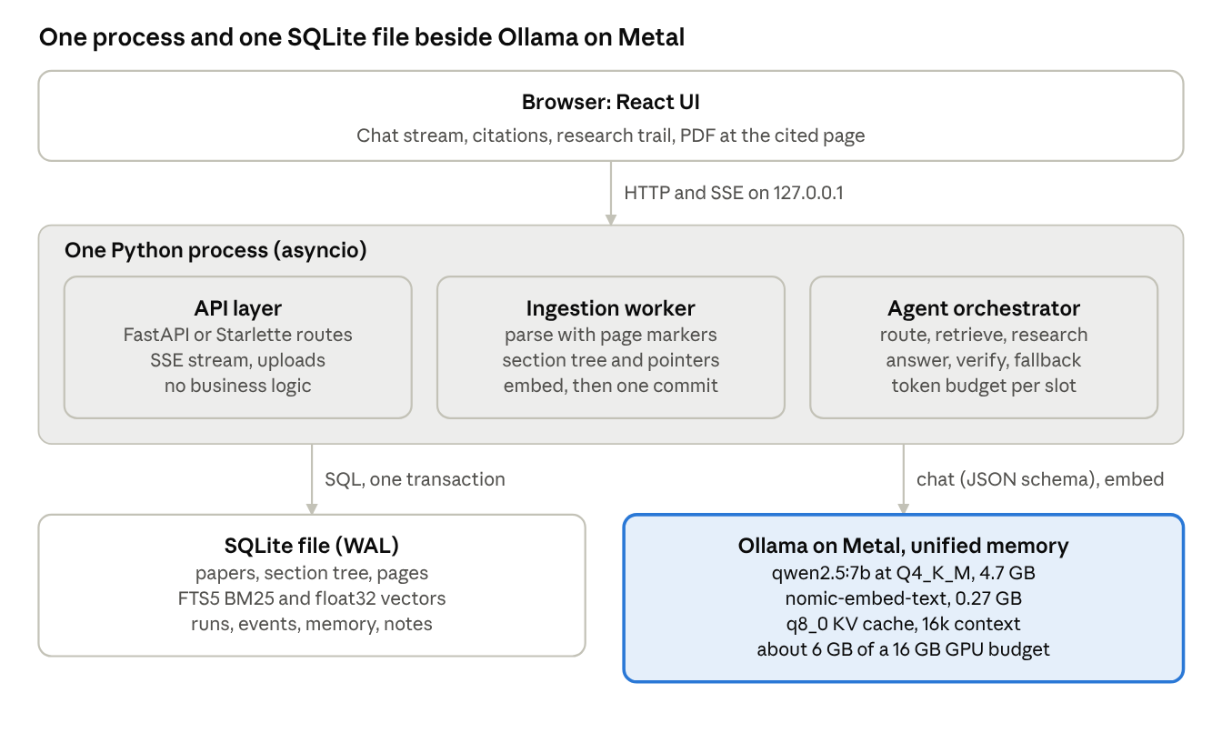
local prototype architecture · 6 components
The highlighted box is the binding constraint: everything else is sized so the model runtime stays inside its memory budget and reads as few bytes per token as possible.

2.1 Hardware facts and what they imply
The base 14-inch M4 Pro has a 14-core CPU (10 performance, 4 efficiency), a 20-core GPU, a 16-core Neural Engine, 24 GB of unified memory and 273 GB/s of memory bandwidth (EveryMac).
- Metal, not MPS, does the inference. llama.cpp (and therefore Ollama) runs on its own Metal backend. MPS is PyTorch's GPU backend, relevant only if you run PyTorch models such as a sentence-transformers embedder or Docling's layout models. Keeping both chat and embeddings in Ollama gives one runtime, one memory account and one place to tune.
- Unified memory removes the PCIe copy. Weights load once into memory the CPU and GPU share, so a 7B model starts quickly and the embedding model can stay resident beside it.
- Decoding is bandwidth-bound. Each generated token reads roughly the whole weight file. A useful ceiling is tokens/s ≈ bandwidth ÷ model bytes: 273 ÷ 4.7 GB ≈ 58 tokens/s for a 7B at Q4_K_M, and 273 ÷ 9 GB ≈ 30 for a 14B. Real throughput lands below the ceiling, so benchmark on your machine. These are estimates, not measurements.
- Prefill is compute-bound. Time to first token grows with prompt length, which is why stable prefixes (KV reuse) and the sources budget matter more locally than raw context size.
- The GPU gets a share, not all, of 24 GB. macOS caps the GPU's working set below total memory, roughly two thirds to three quarters by default. The prototype budgets 16 GB for weights, KV cache, the embedder and runtime overhead, leaving the rest for macOS, the browser and the editor.

2.2 Memory budget per profile
Profile | Generator (Q4_K_M weights) | KV cache at q8_0 | Embedder | Overhead | Total | Fits 16 GB
fast | qwen2.5:3b, 1.9 GB | 16k ctx, ~0.3 GB | 0.27 GB | ~0.6 GB | ~3 GB | Yes
balanced (default) | qwen2.5:7b, 4.7 GB | 16k ctx, ~0.44 GB | 0.27 GB | ~0.6 GB | ~6 GB | Yes
quality | qwen2.5:14b, 9.0 GB | 8k ctx, ~0.75 GB | 0.27 GB | ~0.6 GB | ~10.6 GB | Yes
KV bytes per token = 2 × layers × KV heads × head dim × bytes per value. For qwen2.5-7B: 2 × 28 × 4 × 128 × 2 bytes ≈ 56 KB at fp16, half that at q8_0. Grouped-query attention (4 KV heads instead of 28) is why a 16k context costs under half a gigabyte.
Ollama settings that make this hold: flash attention on (required for a quantized KV cache), OLLAMA_KV_CACHE_TYPE=q8_0, OLLAMA_NUM_PARALLEL=1, OLLAMA_MAX_LOADED_MODELS=2, and an explicit num_ctx on every request. Parallel requests on one laptop GPU split bandwidth and multiply KV memory; serial is faster for a single user.

2.3 Back-end modules
Module | Responsibility | Depends on
config | Profiles, model auto-detection, memory estimate, token budgets | Nothing
llm | Inference port: Ollama and OpenAI-compatible adapters; constrained JSON, re-ask, streaming, embeddings | config
db | SQLite schema, hybrid search (FTS5 BM25 + vectors, RRF), checkpoints, events, memory | Nothing
ingest | Parser (page markers), skeleton tree, sizing, pointers, atomic commit | db, llm
jobs | Persistent ingestion queue, one worker | ingest
agent | Run state, context assembler, tools, orchestrator, run hub | db, llm
memory | Episodes, fact extraction with invalidation, incremental summaries | db, llm
api | HTTP routes + SSE; no business logic | All of the above
Dependencies point one way, and nothing below api imports the web framework, so the core runs equally from the CLI, tests or a worker. For the API layer, FastAPI is the recommended choice for its OpenAPI schema and Pydantic request models. The current prototype uses Starlette, the layer FastAPI is built on, because FastAPI could not be installed in the build environment; the port is mechanical.

2.4 PDF parsing and chunking for small models
- Parse to Markdown with page markers. PyMuPDF4LLM is fast and CPU-only; Docling handles complex tables and layout better but loads PyTorch models (MPS on this Mac) and is slower. GROBID is the specialist for references and bibliographic metadata.
- Chunk by structure, not by characters. Headings become a section tree. Tables and figure captions become their own nodes. Boilerplate (acknowledgements, references) is stored but not indexed.
- Size for the model, not the index. Leaf sections target 300–1,500 tokens; larger ones split at paragraph boundaries and keep their breadcrumb. Pointers are 60–150 tokens: breadcrumb plus lead sentences.
- Why this suits an SLM: a 7B model reasons far better over one intact section than over five fragments with 20% overlap. The token cost is similar, but the coherence is not.

2.5 Local vector index: SQLite and NumPy now, FAISS next, Chroma not needed
The prototype keeps vectors as float32 BLOBs in SQLite and searches an in-memory normalised matrix, which is exactly a FAISS IndexFlatIP. Swap in FAISS (flat to about a million vectors, then IVF or HNSW) behind the same VectorIndex interface when a library grows. Chroma is a reasonable prototype store, but it would be a second persistent database holding metadata that SQLite already owns, which reintroduces the drift problem. By contrast, sqlite-vec, which keeps vectors inside the transaction and is the cleanest embedded upgrade.

2.6 Structured outputs
Every machine-read step is a Pydantic model: RouteDecision, ToolCall, PaperMetadata, Verification. The model's JSON schema goes into Ollama's format field for grammar-constrained decoding (Ollama docs). Pydantic validators then check meaning (ids exist, DOIs match a pattern), and a failed validation is re-asked once with the error text. Constrained decoding guarantees shape; validators guarantee sense.

3. Production architecture
In production, the API holds no state, every long operation goes through a queue, GPUs sit behind a batching inference server, and the database is the only memory the system trusts. The agent loop, schemas and retrieval are unchanged from the prototype.
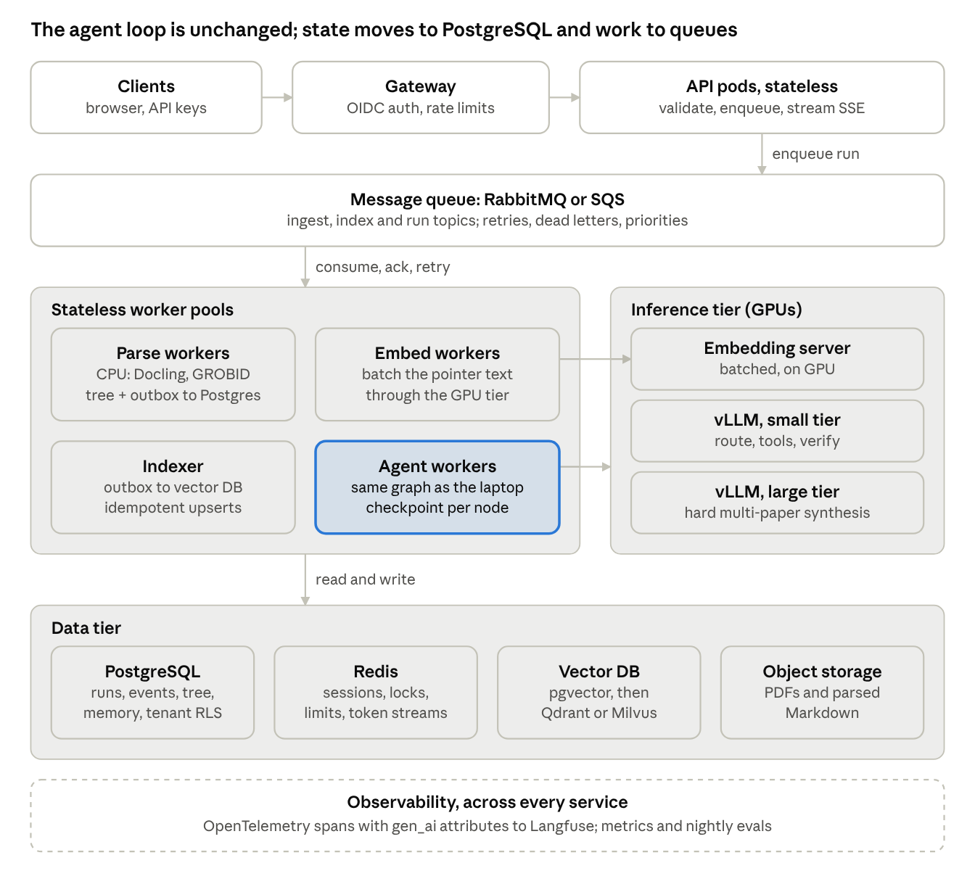
production architecture · 4 tiers
The highlighted agent workers run the same graph as the laptop; what changed is around them: a queue in front, GPUs behind a batching server, and PostgreSQL plus Redis instead of one file.

3.1 Compute and inference
- Serving engine: vLLM pods behind an OpenAI-compatible endpoint. PagedAttention allocates the KV cache in fixed-size pages and returns them to a shared pool, and continuous batching inserts waiting requests at every decode step instead of waiting for a batch to drain (LearnOpenCV). Together they are why one GPU serves dozens of concurrent users rather than one.
- Prefix caching: every request shares the same system prompt and tool schemas, so automatic prefix caching skips their prefill. The stable-prefix discipline from the laptop pays off here at scale.
- Model routing: keep the small model for routing, tool choice, metadata and verification, which are short constrained outputs at high volume. Send final synthesis on hard questions (multi-paper comparisons) to a larger model pool. The router is the same constrained-enum call, now also selecting a model tier.
- Quantization trade-offs: GGUF Q4_K_M suits the laptop's bandwidth limit. On datacenter GPUs, FP8 weights (on hardware with FP8 support) keep quality close to FP16 at about half the memory; INT4 AWQ or GPTQ doubles density again at a measurable quality cost. Choose per tier from your own eval scores, not from leaderboards.
- Scaling signal: autoscale inference pods on queue wait time and KV-cache utilization, not CPU. Cold starts are minutes (weights load), so keep a warm floor and scale out early.
- Triton: worth it when you also serve non-LLM models (rerankers, layout models, classifiers) and want one model server with ensembles. For LLM-only serving, vLLM is the simpler first choice.

3.2 Data and storage
Data | Store | Why
Tenants, papers, section tree, runs, run events, notes, facts | PostgreSQL | Source of truth; transactions; row-level security per tenant
Pointer vectors | pgvector up to roughly ten million vectors, then Qdrant or Milvus (or Pinecone if managed) | Approximate nearest-neighbour search with tenant filters; sharding and replication beyond one node
Keyword index | PostgreSQL full-text search, or the vector store's sparse/hybrid support | Keeps BM25 + vector fusion
Hot session state, locks, rate limits, token streams | Redis | Sub-millisecond reads; TTLs; pub/sub or streams for live tokens
PDFs and parsed Markdown | Object storage (S3-compatible) | Cheap, durable, versioned; the database stores keys
Consistency between PostgreSQL and a separate vector store uses the transactional outbox. The ingestion transaction writes the section tree and an index_requests row together. An indexer consumes the outbox and upserts vectors idempotently, keyed by (tenant_id, node_id). Deletes follow the same path, so the index never serves a section the user removed. Retrieval re-checks hits against PostgreSQL before loading sections, which closes the remaining window.

3.3 Orchestration and concurrency
- Stateless API pods (FastAPI) authenticate, validate, write a runs row and enqueue. They stream results by subscribing to the run's event channel, so a client can reconnect to any pod.
- Queues for all long work. RabbitMQ (or SQS) fits task semantics: per-message acknowledgement, retries with backoff, dead-letter queues and priorities. Kafka fits an event log you want to replay or fan out to analytics; adopt it if you already run it. Celery is a convenient Python task layer over a broker, but a thin aio-pika consumer keeps retries and acknowledgement explicit, in line with the native-code principle.
- Separate worker pools scale independently: parse workers (CPU, Docling and GROBID), embedding workers (GPU), indexers, and agent workers (I/O-bound, mostly waiting on inference, so high concurrency per process).
- Checkpointed runs: an agent worker loads the run, executes one node, checkpoints, and publishes events. A crashed worker's message is redelivered and another worker resumes from the last checkpoint. Tool calls are idempotent or keyed so a replay does not duplicate notes.
- Backpressure: per-tenant concurrency limits in Redis, queue length caps, and a fast "busy, retry in N seconds" response beat unbounded queues that time out silently.

3.4 Observability
- Traces: one trace per run; one span per graph node, tool call and model call. Model spans carry the OpenTelemetry GenAI attributes (gen_ai.operation.name, gen_ai.request.model, gen_ai.usage.input_tokens, gen_ai.usage.output_tokens), which are defined in the OpenTelemetry GenAI conventions repository and still evolving.
- LLM-specific backend: export over OTLP to Langfuse, which accepts OTLP over HTTP and maps GenAI attributes to model, input, output and usage. Keep the same traces flowing to your general APM.
- Metrics that matter: time to first token, decode tokens per second, queue wait, KV-cache utilization, schema-retry rate, fallback rate, citation precision, cost per answered question.
- Evals as monitoring: a fixed question set with gold sections runs nightly and on every prompt or model change; a rising retry or fallback rate is the earliest regression signal.
- Privacy: log prompts and outputs only where policy allows, with redaction; papers can be confidential.

3.5 Guardrails
In this product, the main attack surface is the papers. OWASP ranks prompt injection first among LLM risks and distinguishes text typed by a user from instructions planted in documents the model reads (Giskard summary of LLM01:2025). A PDF can carry white-on-white text that says "ignore previous instructions".
- Ingestion: check file type and size, scan for malware, render-check PDFs, and flag instruction-like text (hidden or not) in parsed sections for review or exclusion.
- Prompt structure: sources go inside delimited data blocks, and the system prompt states that source text is evidence, never instructions.
- Tool layer, deterministic: tools are read-only except tenant-scoped notes, every call is authorized against the caller's tenant in code, and there is no network egress from the agent. An injected instruction then has nothing dangerous to call.
- Output: schema validation; citations must reference sections actually loaded in this run; a verify pass marks unsupported claims; policy and PII filters run before the answer leaves.
- Limits: per-tenant rate and cost budgets, step caps and timeouts, and an audit log of every tool call.
Model-based classifiers help at steps 1 and 4, but the guarantees come from steps 3 and 4 being deterministic code.

4. Local prototype vs production: the pivots
What changes is where each concern lives and what limits it. The agent loop, schemas, chunking and budgets carry over unchanged.
Concern | Local M4 Pro prototype | Production product | Pivot trigger
Compute: binding limit | Memory bandwidth (273 GB/s) and ~16 GB GPU share | GPU utilization and KV-cache capacity under concurrency | More than one concurrent user, or models over ~14B
Compute: serving | Ollama / llama.cpp on Metal, one request at a time | vLLM pods: PagedAttention, continuous batching, prefix caching | Same
Compute: quantization | GGUF Q4_K_M weights, q8_0 KV cache | FP8 or AWQ/GPTQ INT4 per tier, chosen from eval scores | Moving to datacenter GPUs
Compute: scaling | None; profiles trade model size against context | Autoscale on queue wait and KV utilization; warm floor of pods | Latency targets under load
Data: documents and state | One SQLite file (WAL), one transaction for everything | PostgreSQL with row-level security; S3 for files | Multiple writers or tenants
Data: vectors | In-process matrix (FAISS Flat equivalent), ~10^5–10^6 vectors | pgvector, then Qdrant or Milvus for sharded, filtered ANN | Corpus or QPS beyond one node
Data: consistency | Atomic by construction | Transactional outbox + idempotent upserts + read-time re-check | Vectors leave the primary database
Data: hot state | In-process run hub | Redis: sessions, locks, rate limits, token streams | Multiple API pods
Orchestration: execution | asyncio tasks in one process | Stateless workers consuming RabbitMQ/SQS (Kafka for event logs) | Any work longer than a request, or horizontal scale
Orchestration: durability | Checkpoint per node in SQLite; restart marks runs failed | Checkpoint per node in PostgreSQL; redelivery resumes on another worker | Worker crashes must not lose runs
Orchestration: concurrency control | One ingestion worker; one run per session | Per-tenant limits, priorities, dead-letter queues, backpressure | Noisy neighbours
Observability | Structured logs, persisted run events, research trail in the UI | OpenTelemetry traces with GenAI attributes into Langfuse + metrics + nightly evals | Anyone other than the author debugging
Guardrails: injection | Delimited sources, read-only tools, no network | Plus ingestion screening, classifiers, audit log | Untrusted users or shared libraries
Guardrails: output | Schema validation, citation check, verify node | Same, plus policy/PII filters and per-tenant cost budgets | External users
Security and tenancy | Single user, bound to 127.0.0.1 | OIDC auth, tenant isolation at the database and tool layer, encryption at rest | More than one user
Cost model | Electricity; fixed hardware | GPU-hours; cost per answered question becomes a product metric | Paying users
Sequence the pivots by the trigger, not all at once. The usual order is PostgreSQL and the API split first, then queues and workers, then vLLM, and a dedicated vector database last.

5. Migration path: ports and adapters
The move to production is cheap if the core only ever talks to five narrow interfaces. Each interface has a laptop adapter and a cluster adapter; the agent loop, schemas and chunking never import either.
Port | Local adapter (prototype) | Production adapter
InferencePort | OllamaLLM (format = JSON schema) | OpenAICompatLLM against vLLM (response_format json_schema), tier routing
VectorIndex | In-process matrix over SQLite BLOBs | pgvector, then Qdrant or Milvus client
RunStore | SQLite runs + events tables | PostgreSQL, same schema, tenant column + row-level security
JobQueue | asyncio task + papers table as queue | RabbitMQ or SQS via a thin aio-pika / aioboto3 publisher
EventBus | In-memory RunHub | Redis Streams, read from any API pod

5.1 The ports (Python 3.12)
# app/ports.py: the only seams that differ between the laptop and the cluster
from collections.abc import AsyncIterator
from typing import Literal, Protocol
from pydantic import BaseModel
type Message = dict[str, str]
type Tier = Literal["small", "large"]
class InferencePort(Protocol):
async def structured[T: BaseModel](
self, messages: list[Message], schema: type[T], *, tier: Tier = "small", max_tokens: int = 512
) -> T: ...
def stream(self, messages: list[Message], *, tier: Tier = "small") -> AsyncIterator[str]: ...
async def embed(self, texts: list[str]) -> list[list[float]]: ...
class VectorIndex(Protocol):
async def upsert(self, tenant_id: str, items: list[tuple[str, list[float]]]) -> None: ...
async def delete(self, tenant_id: str, node_ids: list[str]) -> None: ...
async def search(
self, tenant_id: str, vector: list[float], k: int, paper_ids: list[str] | None = None
) -> list[tuple[str, float]]: ...
class JobQueue(Protocol):
async def publish(self, topic: str, payload: bytes, *, key: str) -> None: ...
class EventBus(Protocol):
async def publish(self, run_id: str, event: dict) -> None: ...
def subscribe(self, run_id: str, after_seq: int = -1) -> AsyncIterator[dict]: ...
Tenancy enters at the port signature, not as an afterthought in the adapter: a call without a tenant_id does not type-check.

5.2 Stateless API route (FastAPI)
@router.post("/v1/sessions/{session_id}/runs", status_code=202)
async def start_run(
session_id: str,
body: RunRequest, # Pydantic: message length, paper_ids
user: Annotated[User, Depends(current_user)],
deps: Annotated[Deps, Depends(get_deps)],
) -> RunAccepted:
await deps.limits.acquire(user.tenant_id) # Redis token bucket; raises 429
run = await deps.runs.create(user.tenant_id, session_id, body) # PostgreSQL, status=queued
await deps.queue.publish("runs", run.run_id.encode(), key=session_id)
return RunAccepted(run_id=run.run_id)
The pod writes a row and enqueues; it never runs the agent. A client streams GET /v1/runs/{id}/events from any pod, which reads the run's Redis stream from Last-Event-ID.

5.3 Agent worker with checkpointing and tracing
tracer = trace.get_tracer("paper-assistant")
async def handle_run(msg: AbstractIncomingMessage, deps: Deps) -> None:
# Ack on success; an exception rejects the message, and the queue's
# dead-letter policy decides whether it is retried or parked.
async with msg.process(requeue=False):
run_id = msg.body.decode()
async with deps.locks.hold(f"run:{run_id}", ttl_s=300): # one worker per run
state = await deps.runs.load(run_id)
with tracer.start_as_current_span("invoke_agent research", attributes={"run.id": run_id}):
while state.node != "done":
with tracer.start_as_current_span(f"node {state.node}"):
state.node = await deps.graph.step(state) # same nodes as the prototype
await deps.runs.checkpoint(state) # resume point after a crash
Model calls inside graph.step are wrapped once in the inference adapter:
async def structured[T: BaseModel](self, messages, schema: type[T], *, tier="small", max_tokens=512) -> T:
model = self.models[tier]
with tracer.start_as_current_span(f"chat {model}") as span:
span.set_attribute("gen_ai.operation.name", "chat")
span.set_attribute("gen_ai.request.model", model)
raw, usage = await self._complete_json(messages, schema, model, max_tokens)
span.set_attribute("gen_ai.usage.input_tokens", usage.prompt_tokens)
span.set_attribute("gen_ai.usage.output_tokens", usage.completion_tokens)
return self._validate_or_reask(raw, schema, messages) # unchanged from the prototype

5.4 Order of migration
- Introduce the ports in the prototype and move existing code behind them. No behaviour change; tests stay green.
- Swap SQLite for PostgreSQL behind RunStore, and split the API from the worker process. Add OIDC and tenant columns.
- Put ingestion and runs on a queue with a separate worker pool; replace RunHub with Redis Streams.
- Point InferencePort at vLLM; add the large tier and prefix caching; load-test against latency targets.
- Move vectors out of PostgreSQL only when pgvector stops meeting latency or scale targets, with the outbox in place first.

6. Senior interview talk-tracks
Interviewers probe for three things: that you name the binding constraint before proposing components, that every choice comes with what it costs, and that you know where the system breaks first. Each track below is built to be said in under a minute.

6.1 Decisions and their why
Question you'll get | Your answer in one line | The why behind it | Trade-off to volunteer
Why not LangChain or a big agent framework? | Code owns control flow; the model makes bounded, schema-constrained choices. | Small models plan poorly; visible prompts and typed state make failures debuggable and testable. | ~400 lines of loop to own; adopt durable execution only for multi-day workflows.
Why chunk by section instead of fixed size? | Embed small pointers for precision, feed whole sections for coherence. | A 7B model reasons over one intact argument far better than over overlapping fragments. | Oversized sections need splitting; parsing quality now matters more.
Why one database locally? | State, memory, document tree and vectors commit in one transaction. | No drift between a vector store and the source of truth; zero operations. | One writer and one node; that is the pivot trigger.
When would you add Qdrant or Milvus? | When pgvector misses latency or scale targets, never on day one. | Every extra store adds a consistency problem (outbox, deletes, re-checks). | You pay in sync machinery for scale you may not need.
How do you get reliable JSON from a small model? | Grammar-constrained decoding, then Pydantic validation, then one re-ask with the error. | Constraints guarantee shape, validators guarantee meaning, re-ask fixes the rest. | A second call on failure; track the retry rate as a health metric.
How do you stop the agent looping? | Step caps, repeated-call detection, and a deterministic fallback path. | Small models repeat themselves; the user should always get a grounded answer. | Some answers end early; the trail shows why.
Why vLLM over a simple inference server? | Continuous batching and paged KV cache turn one GPU into many concurrent sessions. | The cost driver is GPU-hours per answer, and batching is the biggest multiplier. | More knobs (max sequences, memory fraction); cold starts take minutes.
RabbitMQ or Kafka? | RabbitMQ (or SQS) for jobs; Kafka for event logs you replay. | Jobs need acks, retries, dead letters and priorities; logs need retention and fan-out. | Running both is common at scale, but start with one.
What's your biggest security risk? | Instructions hidden in uploaded papers (indirect prompt injection). | The model reads attacker-controlled text by design. | Classifiers miss things, so the real guarantee is read-only, tenant-scoped tools and output validation.
How do you know it's working? | Traces per run, a fixed eval set run on every change, and citation precision as a product metric. | LLM failures are silent; only measurement catches regressions. | Evals cost compute and maintenance; keep the set small and gold-labelled.

6.2 Bottlenecks, in the order they bite
- Laptop decode speed: bandwidth-bound. Fix with smaller weights (quantization) or a smaller model, not more cores.
- Time to first token on long prompts: prefill grows with prompt length. Fix with section budgets, stable prefixes and prefix caching.
- Ingestion throughput: PDF parsing is CPU-bound and Docling is slow; embedding is GPU-bound. Fix with separate, independently scaled worker pools and batching.
- GPU KV-cache capacity in production: caps concurrent sequences. Fix with paged attention, FP8 KV cache, shorter contexts and routing short tasks to the small model.
- Connection and fan-out limits: thousands of open SSE streams and database connections. Fix with a pooler (PgBouncer), Redis Streams for fan-out and per-tenant concurrency caps.
- Vector search at scale: filtered ANN with many tenants. Fix with tenant-partitioned collections or payload indexes, then sharding.

6.3 Back-of-envelope numbers to have ready
State assumptions out loud; the method matters more than the digits.
- Decode ceiling: tokens/s ≈ memory bandwidth ÷ bytes read per token. M4 Pro, 7B Q4_K_M: 273 GB/s ÷ 4.7 GB ≈ 58 tokens/s upper bound.
- KV cache per token: 2 × layers × KV heads × head dim × bytes. Qwen2.5-7B at fp16: 2 × 28 × 4 × 128 × 2 ≈ 56 KB, so 16k tokens ≈ 0.9 GB (half at q8_0).
- Concurrency on one 80 GB GPU (estimate): a 7B model in FP16 is ~15 GB of weights, leaving roughly 60 GB for KV after runtime overhead. At 56 KB per token that is about a million cached tokens, or roughly 130 concurrent sessions at 8k tokens each, before throughput, not memory, becomes the limit.
- Ingestion cost: a 20-page paper yields roughly 40–80 sections, so 40–80 pointer embeddings plus one metadata call; parsing usually dominates wall time.
- Context budget at 16k: system 900 + tools 500 + memory 800 + history 3,000 + sources 7,800 + output 1,500 = 14,500 tokens, about 90% of the window, leaving margin for token-estimate error.

6.4 How to open the system design answer
"The binding constraint on the laptop is memory bandwidth and a 16 GB GPU budget, so I minimise bytes per token: a 7B at 4-bit, a quantized KV cache, and retrieval that feeds whole sections under a hard token budget. In production the constraint becomes GPU utilization under concurrency, so I keep the same agent loop and schemas but put them behind stateless workers, a queue and a batching inference server, with PostgreSQL as the only source of truth. The seams that make that move cheap are five narrow interfaces. The biggest risk is instructions hidden in uploaded papers, which I contain with read-only, tenant-scoped tools and validated, citation-checked output."

Sources
Throughput, memory and concurrency figures without a link are estimates derived in this doc from the formulas shown; measure them on your hardware.
- Apple MacBook Pro M4 Pro 14-core CPU, 20-core GPU specs — EveryMac
- Building effective agents — Anthropic
- Effective context engineering for AI agents — Anthropic
- Structured outputs — Ollama docs
- Automatic prefix caching — vLLM docs
- vLLM: PagedAttention and continuous batching — LearnOpenCV
- OpenTelemetry GenAI semantic conventions — GitHub
- OpenTelemetry integration — Langfuse docs
- OWASP LLM01:2025 Prompt Injection — Giskard glossary

